

SIGMA Clermont
Campus de Clermont-Ferrand – CS 20265 – 63178 Aubière– France
Tél. +33 (0)4 73 28 80 00 – Fax +33 (0)4 73 28 81 00 –https://www.sigma-clermont.fr/
Control of robotic manipulators for contact-based tasks performed in collaboration with humans for industrial applications

2nd year internship report

Presented by
Titouan BRIANCON
Company : Citius

Company supervisors : Juan Antonio CORRALES RAMON

Academic supervisor :

Date : september 2025
Reference du fichier : Briançon_Titouan_RapportStage2A.pdf


FICHE D’IDENTIFICATION DU DOCUMENT
Rapport de Stage 2ère Année

TITRE DU DOCUMENT : |  | Contrôle de manipulateurs robotisés pour des tâches de contact réalisées en collaboration avec des humains pour des applications industrielles
 |  | Control of robotic manipulators for contact-based tasks performed in collaboration with humans for industrial applications
AUTEUR(S) : |  | Titouan Briançon – IMR - MRS
Date du document | Nbre de pages |  | Référence du document
 | XVII |  | Briançon_ Titouan_RapportStage2A.pdf
ABSTRACT:

Keywords: ROS, Arm robot, Python
RESUME :
Ce document présente une structure à utiliser dans la rédaction des rapports de stage 1A. Il donne également quelques conseils pour une bonne rédaction.
Mots clés : rapport, projet, rédaction
Visa de l’entreprise :
Ce rapport de stage a été visé par (Nom, Prénom, Qualité) : ……………………………………..
Date :
Signature :

Je demande que ce rapport soit confidentiel (non diffusé sur l’intranet de l’école) : OUI NON

SIGMA Clermont
Campus de Clermont-Ferrand – CS 20265 – 63178 Aubière– France
Tél. +33 (0)4 73 28 80 00 – Fax +33 (0)4 73 28 81 00 –http://www.sigma-clermont.fr/
Table des matières
acknowledgment 5
Chapitre 1. Presentation of the internship 7
1.1. Project 7
1.2. Laboratory 7
1.3. Presentation of the used robot, sensors and informatic architecture 9
1.3.1. UR5e 9
1.3.2. UR30 9
1.3.3. Teach pendant / UR script 10
1.3.4. Bota sensors 11
1.3.5. ROS and Ubuntu 20.04 11
1.3.6. Moveit / Gazebo 12
Chapitre 2. Admittance control 13
2.1. Model 13
2.2. UR30 configuration 13
2.3. The code 15
2.3.1. Method 15
2.3.2. Setup with GitHub 17
2.4. UR5e configuration 17
Chapitre 3. The handle 18
3.1. Material used 18
3.2. Data analysis 21
Chapitre 4. Next steps 22
4.1. Admittance 22
4.2. Handle 22
Chapitre 5. Conclusion 23

acknowledgment

This document is created to summarize my main tasks I completed during my fourth-month internship at Citius in Spain.

This document is also a resource for future members of this project, to help understand of the work done.

Firstly, I would like to express my deep gratitude to Mrs Mezouar, who participated at the exitance of this internship in Spain.

I express also thanks to Matteo, William and Axel who greatly contributed to the internship.

Presentation of the internship

Project
This second-year engineering internship, lasting four months (17 weeks), is part of the robotics specialization. It offers a practical immersion into the industrial world, providing an opportunity to apply advanced technical skills in human-robot interaction.
The main objective of the internship is to implement an admittance control on a UR30 robotic arm to assist in meat cutting operations in the butchery sector, as part of the ROBOTA-SUDOE project. This project is part of a collaborative automation approach, aiming to enhance the precision, safety, and efficiency of manual tasks in a demanding environment.
I was involved in a hands-on project that combined modelling, industrial robot programming, and sensor integration, while working closely with multidisciplinary teams. This experience allowed me to develop skills in admittance and impedance control, to explore the challenges of robotic manipulation in semi-structured environments, and to gain a deeper understanding of the role of physical assistance in manual and craft-oriented tasks.

Laboratory
The internship was conducted at CiTIUS (Centro Singular de Investigación en Tecnoloxías Intelixentes), a flagship research center within the Campus Vida of the University of Santiago de Compostela, founded in 2010 and accredited in 2012 on this campus.
CiTIUS employs around 100 researchers, including some 33 senior scientists, and is organized into 10 scientific programmes spanning intelligent hardware design, high-performance computing, machine learning, augmented/virtual reality, vision, language technologies, and notably robotics among others.
Within this vibrant research ecosystem, I joined the Robotics programme, which focuses on collaborative and assistive robotic systems. The labs are equipped with multiple cobots namely the UR5e and the new UR30, which offers a 30 kg payload and 1.3 m reach alongside others such as the Franka Emika Panda and Omron TM.
The experimental infrastructure includes force/torque sensors, tactile systems (Contactile, Gelsight), and 3D vision setups. Additionally, the facility features a MakerLab with 3D printers and electronics workbenches, enabling swift prototyping and hardware integration in a semi-structured testing space. The centre also provides collaborative offices to support team-based research and discussions.
This combination of advanced robotics platforms, sensor technologies, and a multidisciplinary research culture created an ideal environment for developing and testing the admittance control on the UR30, aimed at assisting meat-cutting operations.

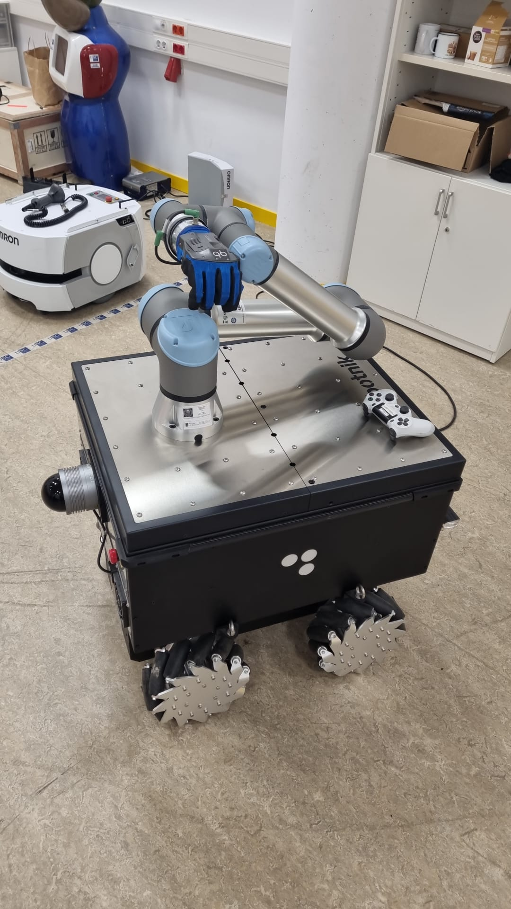
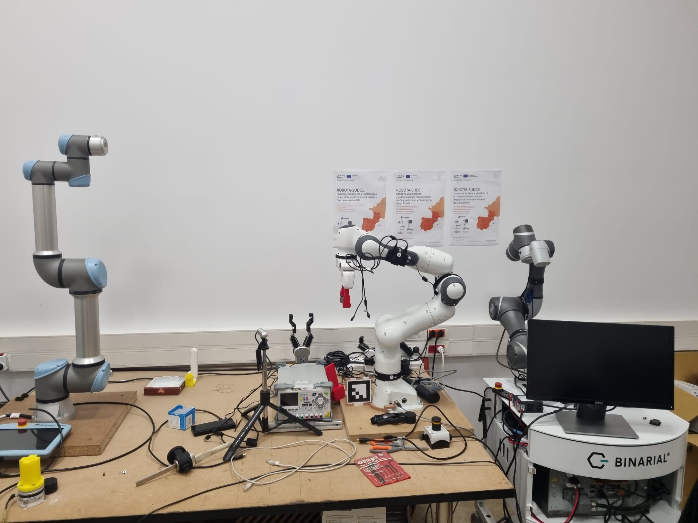
During the internship, we had access to several rooms for different tasks, most of the time I was in the robotics laboratory, which contains not only the robots we used but also other robotic devices.
Figure 1 : RB-KAIROS
Figure 2 : UR5e, Franka Emika and TM5M-700

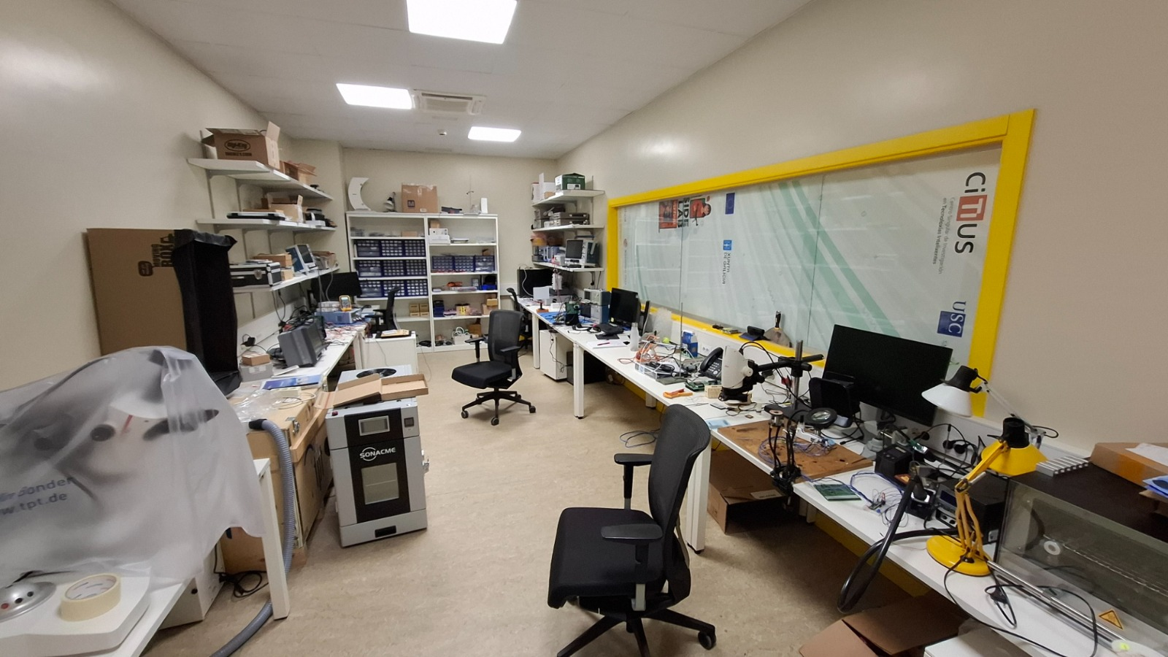
We used also the micro-electronics laboratory to soldering:
Figure 3 : micro-electronics lab

Presentation of the used robot, sensors and informatic architecture

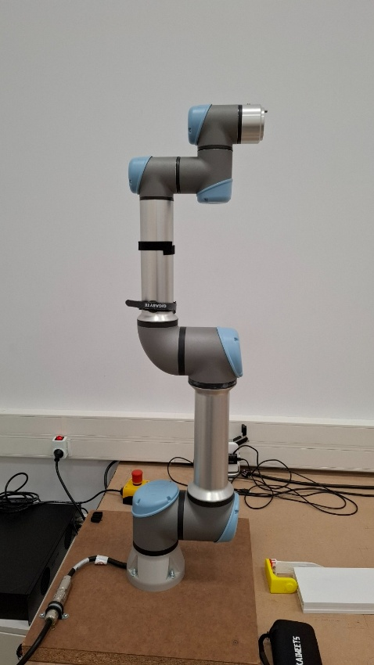
UR5e
The UR5E robot is a 6-axis collaborative cobot developed by Universal Robots in Denmark. It has a 5 kg payload capacity and a reach of 850 mm. A torque/force sensor in the wrist protects the user during interaction, enabling safe operation without physical barriers. With a repeatability of ± 0.03 mm and a maximum joint speed of 180°/s, it excels at precision assembly, screwing and pick-and-place tasks. Weighing only 20.6 kg and rated IP54 for dust and splash resistance, it can be deployed across diverse environments. Programming is done via the intuitive Polyscope teach pendant, and the open URCaps architecture allows seamless integration of grippers, vision systems or other tools. It is also widely used for education and training, thanks to its user-friendly interface and robust community support.

Figure 4 : UR5e

UR30

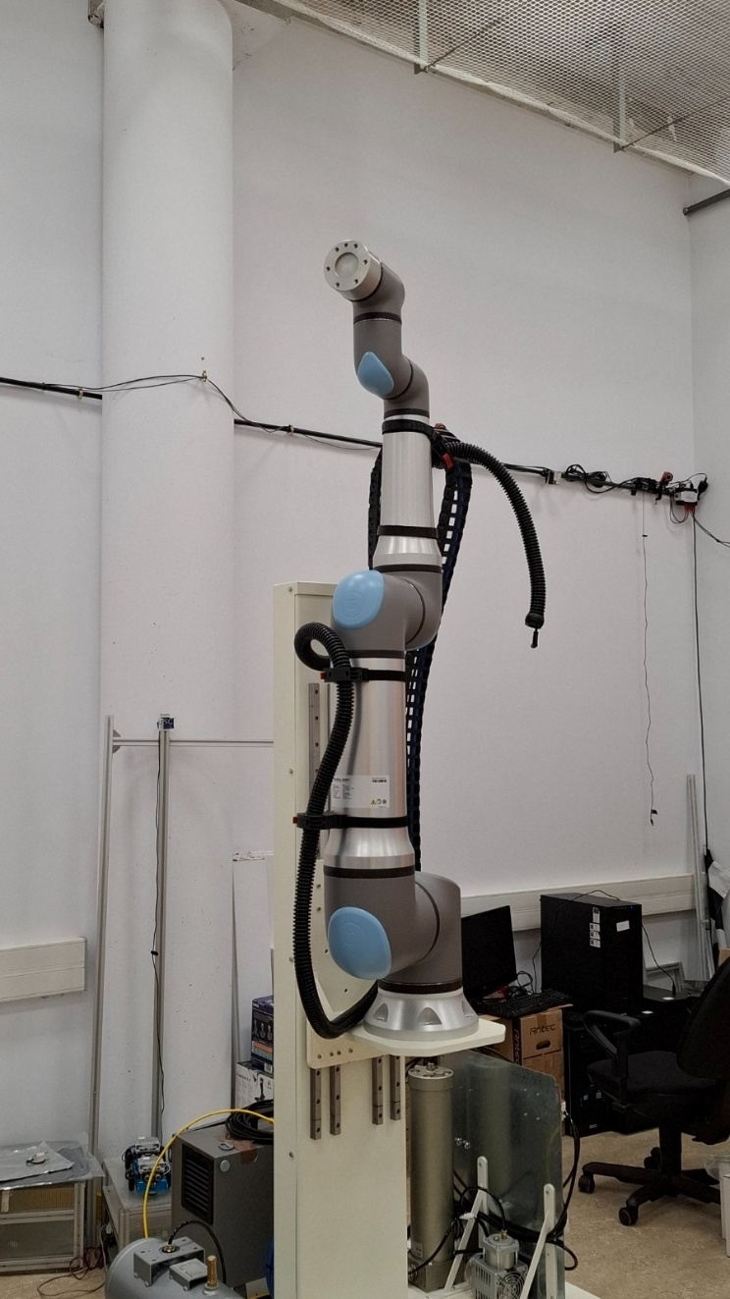
The UR30 robot is a 6-axis collaborative cobot developed by Universal Robots in Denmark. It offers a payload capacity of 30 kg and a reach of 1300 mm. Equipped with a force/torque sensor at the tool flange, it ensures safe human interaction by detecting collisions and adapting its motion in real time. With a repeatability of ± 0.1 mm and a maximum TCP speed of 4 m/s, the UR30 excels at precise placement of heavy parts in tasks like palletizing and high-torque screw driving. Rated IP 65 for the arm and IP 44 for the control box, it can be reliably deployed in challenging industrial environments. Weighing 63.5 kg with a compact Ø245 mm footprint, programming is handled via the Polyscope touchscreen teach pendant, while the URCaps ecosystem allows seamless integration of grippers, vision systems, or other end-effectors, making it well-suited for quick deployment, reconfiguration, and education or training settings.

Figure 5 : UR30

Teach pendant / UR script
The teach pendant (Polyscope interface) of Universal Robots is the touchscreen used to commission the cobot, “teach” it by manually guiding the joints, define waypoints, tune safety parameters (speed ranges, force limits, zones), and build programs as block-based sequences. Under the hood, these programs are translated into URScript, the controller’s native interpreted language. URScript exposes motion primitives (e.g., `moveJ`, `moveL`, `speedj`, `servoj`), I/O handling, threading, and socket communications, enabling precise and repeatable arm control. In this project, the teach pendant was used for core tasks (initialization, activation, validation of poses and tool), while real-time execution is handled by the controller, which consumes velocity and position setpoints provide from an external control with ROS nodes, which are transform into an UR script by the ROS UR driver. In short, the teach pendant is the operator-facing interface for setup and safety, and URScript is the “machine layer” that runs low-level commands deterministically on the controller.

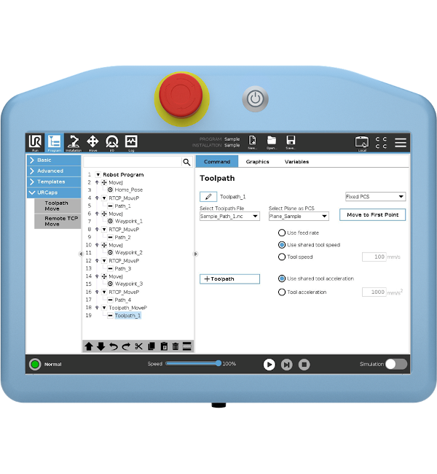
Figure 6 : teach pendant

Bota sensors

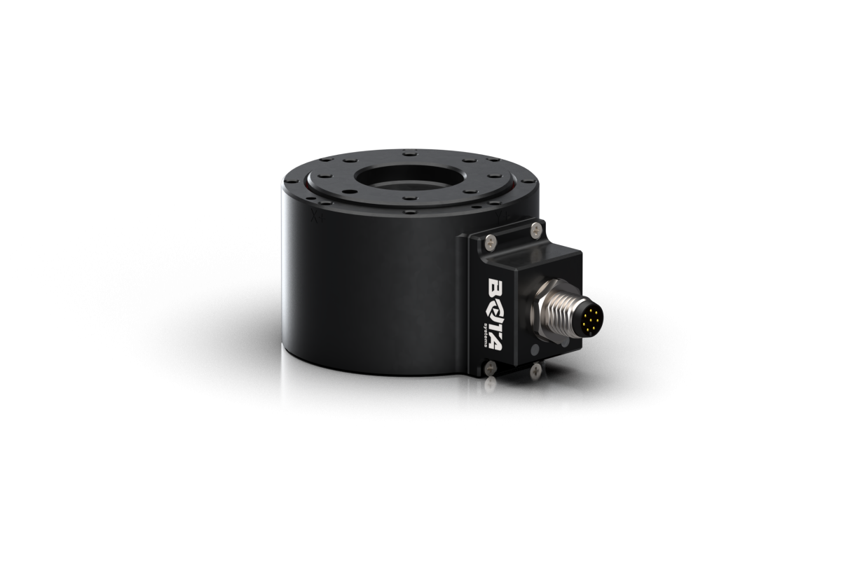
The FT Rokubi by Bota Systems is a compact 6-axis force/torque sensor (Ø48 mm, 120 g) for sensitive robotic applications. It measures up to 500 N and 15 Nm with resolutions of 0.20 N and 0.004 Nm (EtherCAT). Features include 1 kHz sampling, integrated IMU (EtherCAT), and built-in filtering. Interfaces: EtherCAT, RS422, USB, compatible with ROS or MATLAB. Ideal for assembly, polishing, haptics, surgical robotics, and research. Available in both “Serial” and “EtherCAT” versions: Serial (RS422/USB) sends data point-to-point via simple frames for straightforward integration; EtherCAT is a deterministic real-time fieldbus that links multiple devices in a daisy chain with microsecond-level synchronization.

Figure 7 : Bota Rokubi

ROS and Ubuntu 20.04

We worked with Ros, an ecosystem which enables us to communicate easily with the robots. The Robot Operating System (ROS) is an open-source collection of software libraries and tools that provides a standardized middleware layer for building modular, distributed robotic applications. Rather than functioning as a traditional operating system, ROS offers a flexible communication framework using “topics,” “services,” and “actions” to enable interprocess messaging and coordination among independently running software components (nodes). It also supplies hardware‐abstraction interfaces to control sensors and actuators, plus a rich ecosystem of off-the-shelf packages for tasks like navigation, perception, and motion planning. By promoting reusable modules and encouraging the sharing of code within the research and industrial communities, ROS accelerates development, enhances portability across different robotic platforms, and supports scalable, complex system architectures.
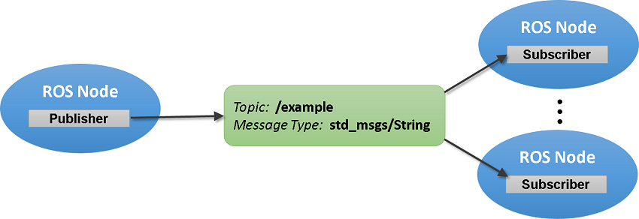
Figure 8 : Basic ROS architecture

Ubuntu 20.04 was chosen as the operating system to support the development and execution of ROS. Ubuntu is a Linux-based distribution widely used in robotics because of its stability, open-source ecosystem, and strong compatibility with ROS packages. The 20.04 Long Term Support (LTS) version provides a reliable environment for real-time applications, with guaranteed updates and community support until 2025. Its widespread adoption in both academic and industrial robotics facilitates integration with external tools and ensures long-term maintainability of the project.

MoveIt / Rviz / Gazebo
MoveIt is an open-source motion-planning and manipulation framework for ROS. Starting from a robot’s URDF/SRDF description, it builds kinematic groups and a 3D planning scene that supports collision checking, constraints (joint, pose, orientation), and trajectory generation via inverse-kinematics solvers and planning pipelines. It provides C++/Python APIs (the MoveGroup interface) and an RViz plugin to define goals, visualize plans, and execute trajectories through ROS controllers, with optional 3D sensor integration to keep the scene updated. MoveIt is well suited to structured manipulation tasks (pick-and-place, assembly). However, because it isn’t designed for strict hard real-time control, reactive behaviors like admittance control are better implemented through direct joint-velocity control. We still used it for simple task, for some tests or to implement things which were not in the project.

We used Rviz, a ROS’s 3D visualization tool, to inspect TF frames, visualize UR models and the MoveIt planning scene. It’s useful to manipulate the robot safely with Moveit, and to diagnose kinematic issues.
We also used Gazebo, which is a physics simulator that can imitate the real robot, with similar topics to control it. It’s useful when we were not working with moveit, but directly with the joint velocities of the robot.

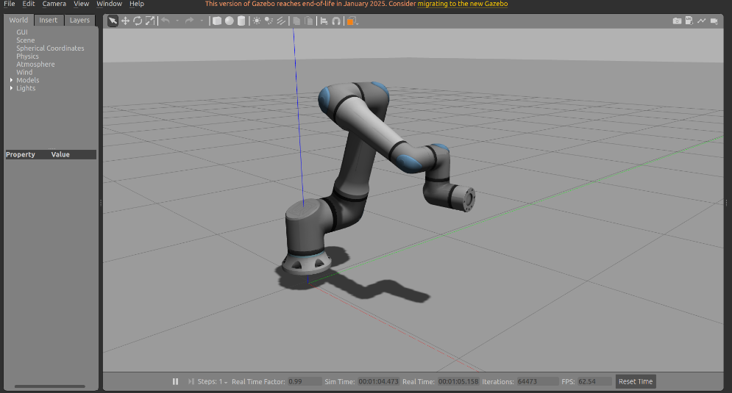
Figure 9 : Gazebo / UR30

Admittance control

Model
The first step after familiarised with the robot, was to implement an admittance control on the UR30. In the context of moving the robot with a force applies by a human, the appropriate model is the mass-damper-spring system:
$$M_{v}\left(\overset{¨}{x}\right)+B_{v}\left(\overset{˙}{x}\right)+K_{v}\left(x-x_{d}\right)=F$$
Where M_{v}, B_{v}, K_{v}, are the virtual inertia, damping and stiffness of the robot, x is the position of the end-effector in the robot’s base frame and x_{d} the desired position. In our case, we use the force applied on the robot to compute the desired position at first, then the joint velocities.

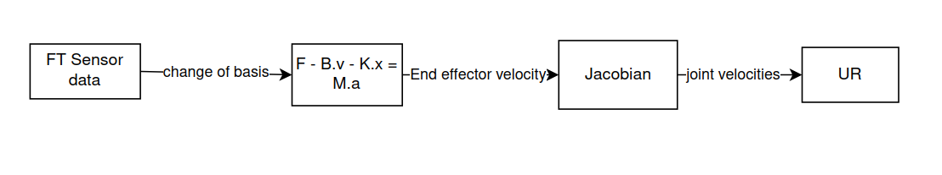

UR30 configuration
At the beginning, we didn’t receive yet the final blade and handle, so we made a temporary setup with 3D printer, which later helped us to make parallel test:

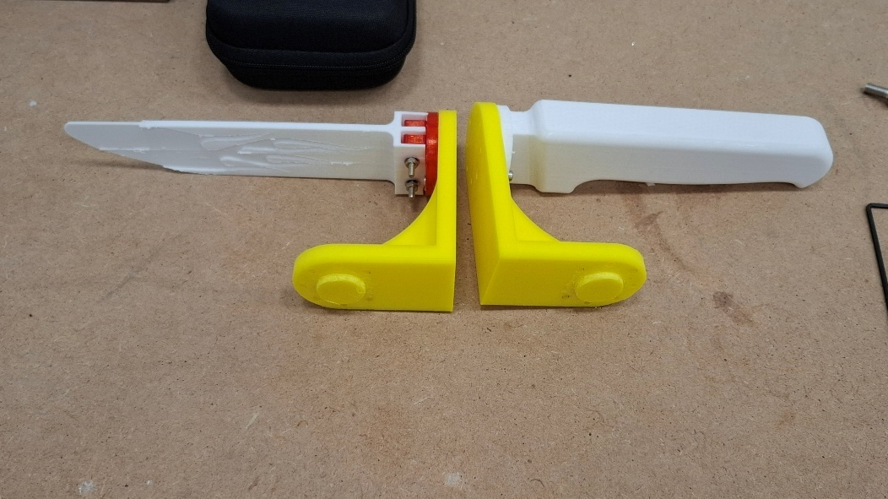
Figure 10 : 3D printed setup

We finally used the metallic setup:
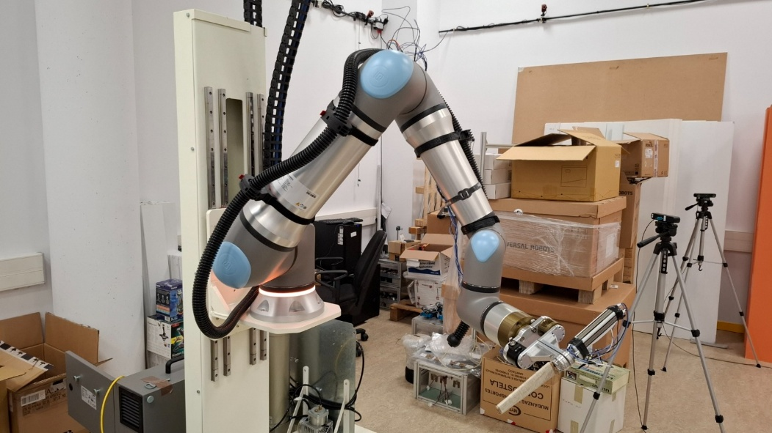
Figure 11 : final setup / UR30
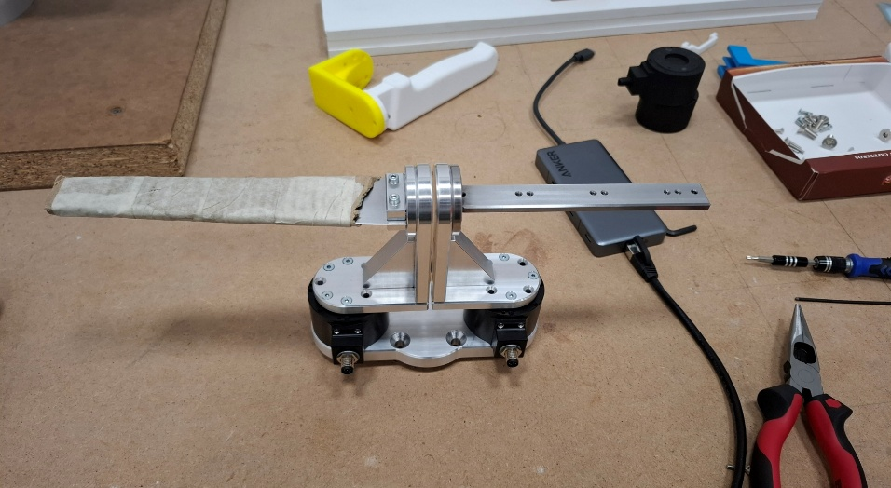
Figure 11 : metallic setup
Figure 12 : metallic setup

Figure 12 : final setup / UR30

We use the 2 “Rokubi” sensors, one on the handle to acquire the force applied by the human and one to acquire the force applied on the blade (useless in the admittance control). During the first weeks, we used plastic support (printed) in order to let us manipulate the robot even if we didn’t have the real support yet.
We had some difficulties with the EtherCAT version of the Rokubi, because this protocol is more complex than the serial one, and needs special driver to work, with special configuration in the computer. The main reason is that with serial protocol we use an USB port to acquire “raw data”, whereas with EtherCAT we use ethernet port, which has more security. The second reason is because usually EtherCAT devices are used with EtherCAT network card, and that our computers have only a classic ethernet network card.

The code

Method
Once the admittance code is functional, we were confronted at one major issue: the frequency. The first version of the code only ran at 100 Hz whereas it is advisable for an admittance control to have at least 500 Hz. At first, we began to analyse our code, in order to identify which parts slow it down. The first problem was that we manage the robot’s movement with Moveit, because it provides a simple movement control, and the Jacobian matrix. However, it is not suitable for a real time control like an admittance, it is used for “pick and place” movement. To fix it, we removed Moveit and we replaced it by a direct control of the joint velocities and another method to compute the Jacobian matrix. Finally, after doing that, and after optimized the code, we reached 350/400 Hz.
Later during the internship, we learnt that for the real time control, python is clearly less efficient than C++, because it is not interpreted language like python, and so there is less jitter and delay. Also, a lot of real time ROS method are only with C++. So finally, we used C++ for the admittance, and it reaches 3000 Hz. Knowing that the maximal frequency of the robot is 500 Hz, we can limit the code to 500 Hz with a very low jitter and delay, and a better real time control, so we reach the optimal configuration for this robot.

This is a simplified rqt graph which explains the architecture of the code, and its ROS interactions. The first one is the first code, which was too slow, and the second is the one with the improvement.

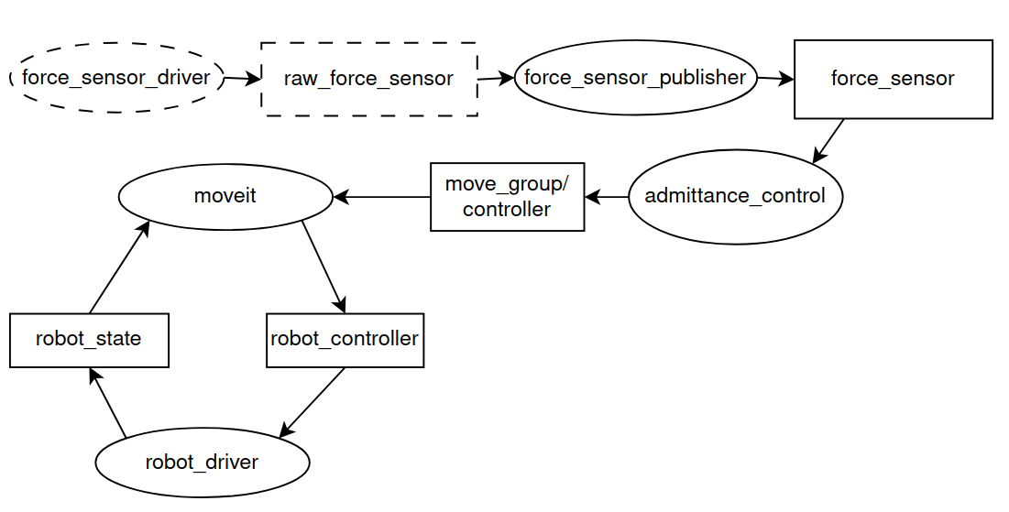
Figure 13 : ROS architecture for the admittance with Moveit

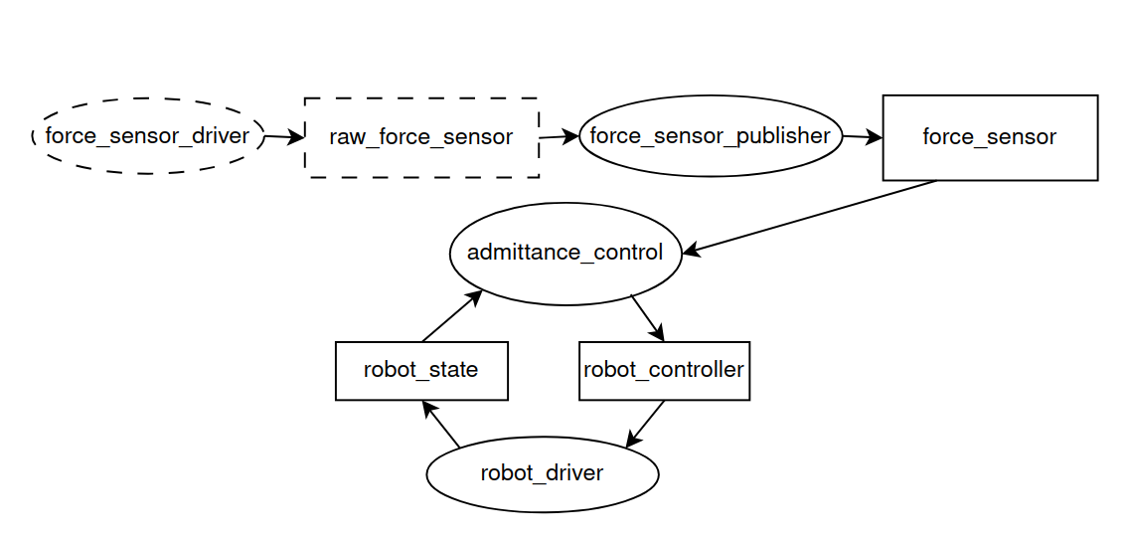
Figure 14 : ROS architecture for the admittance without Moveit

The second problem was the model’s parameters, which impact the robot comportment during the admittance. Firstly, in our case we don’t need that the robot moves back at the initial position, so we set K_{v}= 0. The virtual mass and damper have an impact on the robot’s dynamic, and the faster the robot is, the less stable it is. We didn’t find an optimal combination, but we found a range of values which work correctly without instabilities.
As we didn’t use any library which could move the robot directly (like Moveit), the code is “raw”, therefore the force data from the sensor and the joint velocities are very noisy, so we implemented several exponential filters to ensure stable values. We implanted some safety functions, thanks to the data from the robot driver, we can retrieve the positions of each joint and control their position in the space to avoid contact.
Because of the precedent subject, we had also a problem with the singularities. A singularity is reached when 2 consecutives joints are aligned, which causes that the values of the Jacobian are very close to 0, and so the inversed matrix is huge which causes huge variations in speed and creates instability. To avoid that, we implemented SVD (Singular Value Decomposition) with DLS (Damped Least‐Squares).
The SVD is a mathematical decomposition which write the Jacobian matrix like this:
$$J = U Σ V^{T}$$
With ∑ a diagonal matrix with the singular values $σ_{i}$ of J, U and V orthogonal matrices. The singular values of J give an idea of the facility that the robot has to move in certain directions, when these values are close to zero, that means that the robot is close to a singular position.
The DLS is the fact that we rewrite the basic formula used to calculate the end effector velocity:
$$\dot{x} = J \dot{q} into \dot{q}=J^{T}{\left( J{ J}^{T}+λ^{2}I\right)}^{-1} \dot{x}$$
With $λ$ the damper factor. We have now:
$$σ_{i}^{'}=\frac{σ_{i}}{σ_{i}^{2}+ λ^{2}} and 0≤\frac{σ_{i}}{σ_{i}^{2}+ λ^{2}} ≤\frac{1}{2λ}$$
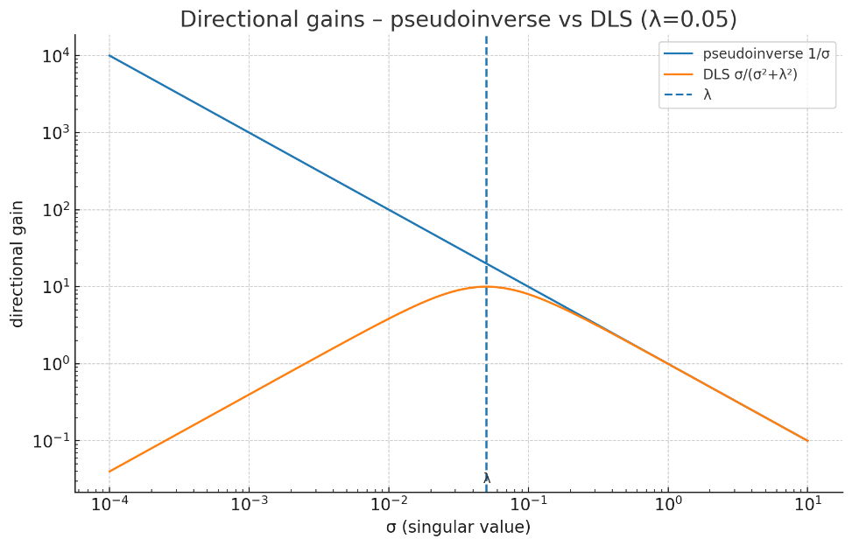
Figure 15 : Directional gains

Thanks to that, and with a correct value for $λ$, when the robot position gets closer to a singularity, and that the singular value $σ$ is close to 0, so the directional gain avoids the large values.

Setup with GitHub
In order to able an easy portability of the work, we created a GitHub repository: https://github.com/titouanbri/titou_ws, which contains all the folders useful to the admittance and all the steps to install it on a computer in the readme file. The nodes and the launch files used for the admittance are in the following package : src/universal_robot/carnicero.

UR5e configuration
Being a very recent robot, our UR30 encountered a software problem, which made it unusable during for a few weeks. While waiting, we used the UR5e:
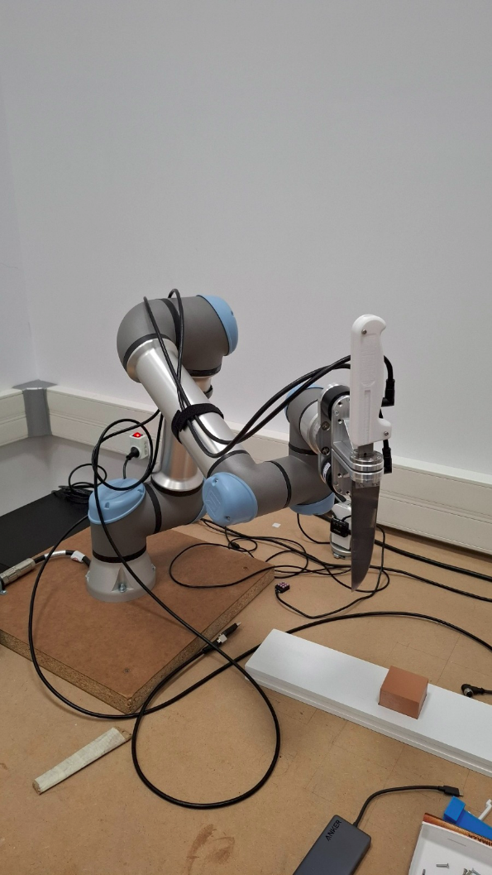
Figure 16 : UR5E setup

The problems with this configuration were that the parameters of the admittance model are not the same and as the segments are shorter than the UR30’s ones, the robot can easily approach singularities, which complicated the advancement of the project. However, we have limited the singularity problem by modifying the calculation of the Jacobian matrix.

The handle

Material used

The second topic is about the handle: in the future of the project, they will implement an AI to predict the movement of the knife to change in a dynamic way the parameters of the admittance model. Our role was to set up and prepare the handle.

To do this, we decided to divide the handle in 6 different areas, in order to identify the areas of strength. We positioned sensors in each area:

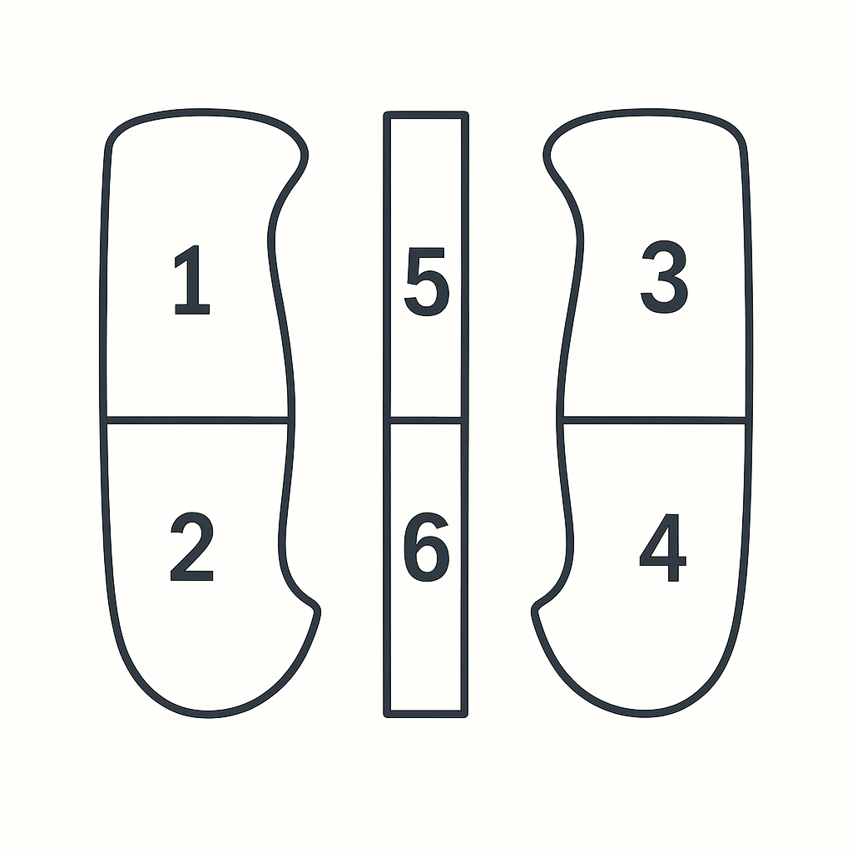
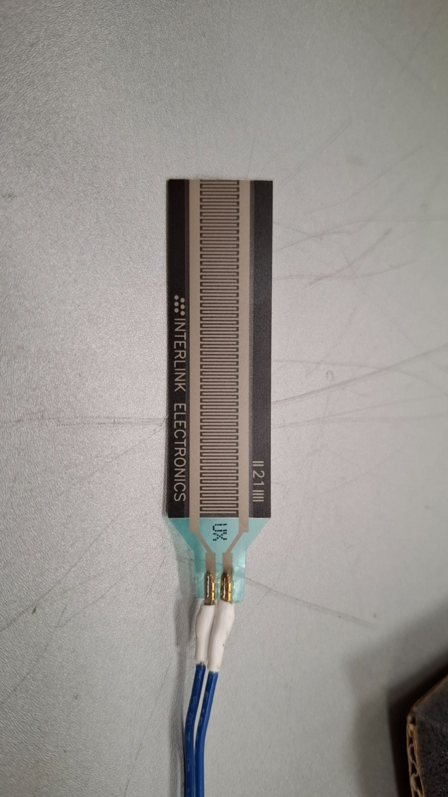
Figure 17 : sensor positions on the handle
Figure 18 : pressure sensors used

these sensors act like variable resistor, so in order to read the data, we used this simple installation with a teensy card:
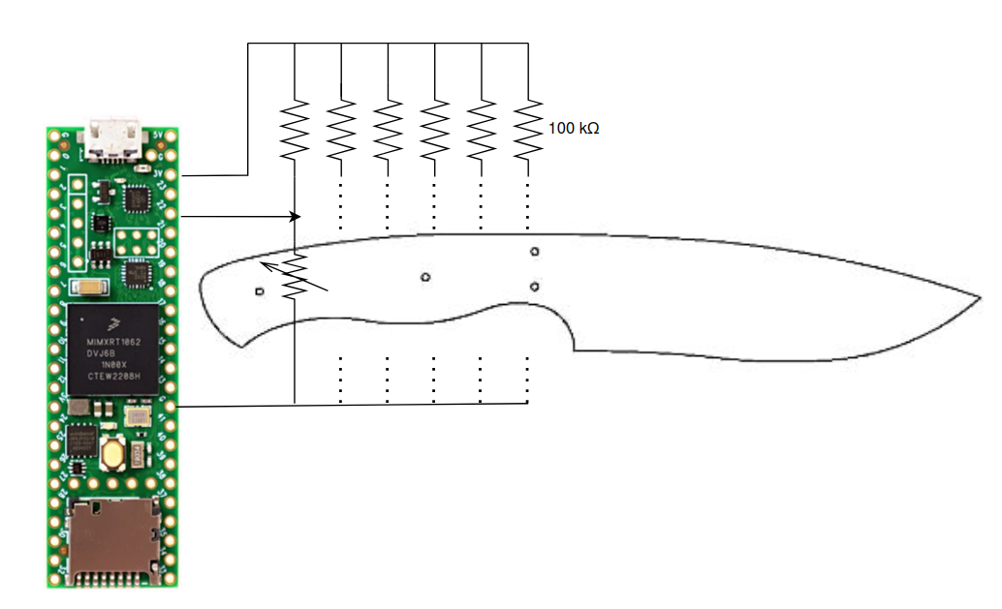
Figure 19 : global architecture

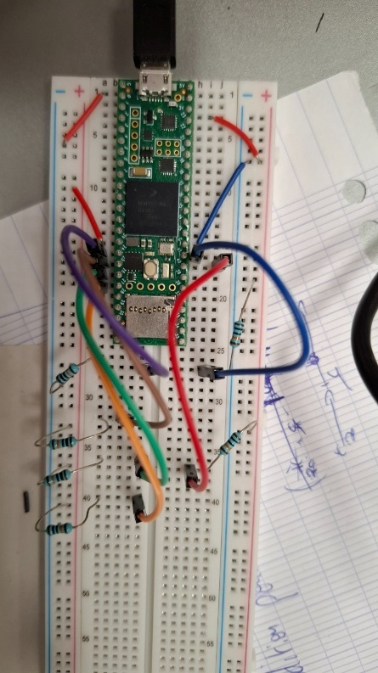
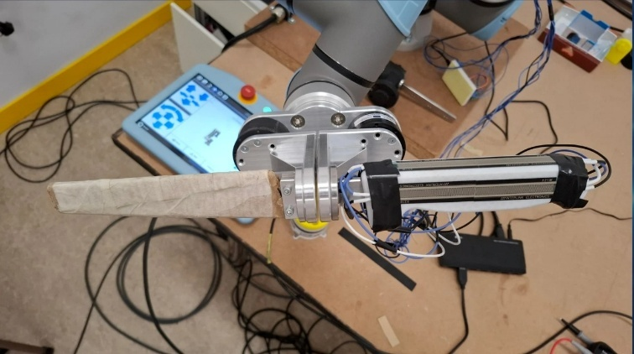
Figure 20 : teensy setup
Figure 21 : real setup for the acquisition

We also had the chance to use a very elaborate sensor, the TactileGlove from PPS. The TactileGlove works by using 65 embedded tactile sensing elements distributed across the palm and fingers. These sensors measure the pressure exerted by the hand in real time and transmit the data wirelessly via Bluetooth Low Energy to a computer running the Chameleon software. The software processes and visualizes the pressure distribution, enabling precise analysis of hand interactions, grip forces, and ergonomics during natural tasks.

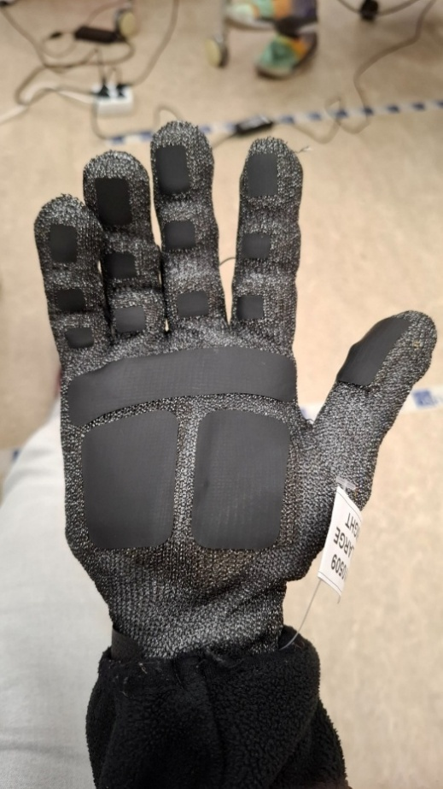
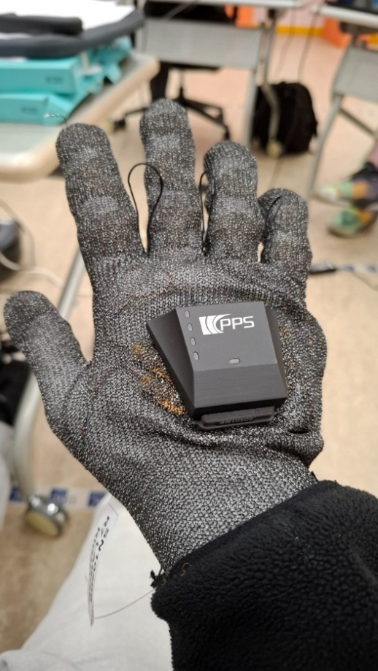
Figure 22 : TactileGlove / palm of the hand
Figure 23 : TactileGlove / back of the hand

firstly, our mission was to determinate the hand position on the handle (“dagger” or “standard”) without AI. We conducted several tests to identify a pattern which enables us to identify the hand position, and we found that with only 2 sensors well chosen, we are able to predict the position with a quite good precision.

Data analysis

In order to compare the force applied on the handle with the force applied with the blade, they decided to use 2 independent parts, with one sensor on each, like we can see on the figure **(celle au dessus). Unfortunately, before the data acquisition, we broke the serial sensor by a careless mistake, we swapped the connexion cable of the serial one with the EtherCAT one, but even if they have similar appearance, they are not powered in the same way. The serial one is directly powered by the serial connexion with the computer, whereas the EtherCAT one is powered by an external source, what broke the serial one by an overpowering.

To continue with the acquisition, it was decided to take a sensor from another robot that we don’t use and to fix it on the desk, in order to put the blade in a part designed especially for this this task and make us able to acquire the data from the blade.

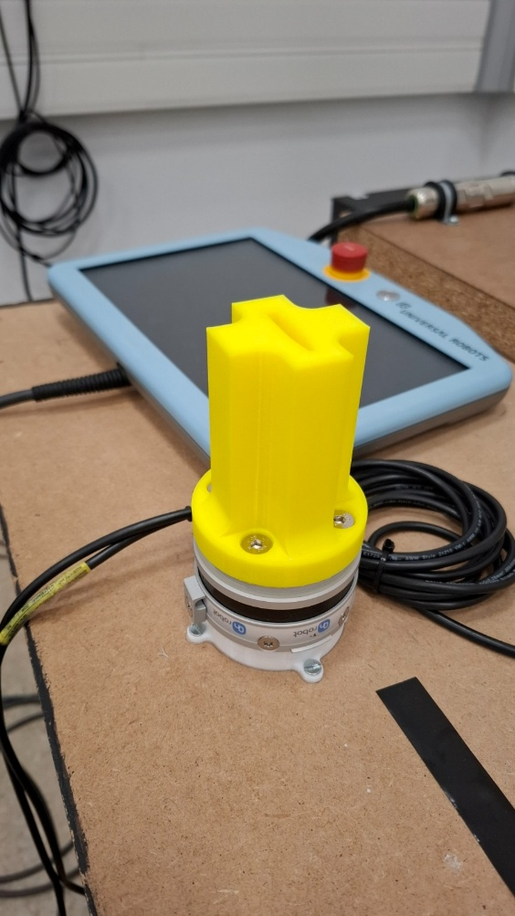
Figure 24 : setup for the data acquisition

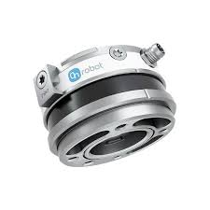
Figure 25 : HEX-E v2

This sensor is the HEX-E v2 from Onrobot, an FT sensor normally used with arm robot. It uses also the EtherCAT protocol, but for this one there is no official driver, and so we had to use opensource driver without a lot of knowledge in this field.

Next steps

Admittance
At the end of the internship, the admittance node can control the robot with any of the 4 FT sensors, which are on the figure ?? (celle UR30) : the 2 Rokubi sensors, the sensone sensor and the internal sensor of the UR (grey on the picture). A next goal should be to determine which are the more appropriate sensor for the admittance control, with several test with each sensor. Moreover, we use a cpp node to control the robot, which is a close real time control, but there is another better method with real time kernel which might improve the robot behaviour.

Handle
Our sensor setup, which was useful to data analysis, will be probably limiting for the IA implementation. So, we tried another handle setup, which was sent by a collaborator, a 3D printed handle with integrated sensors.

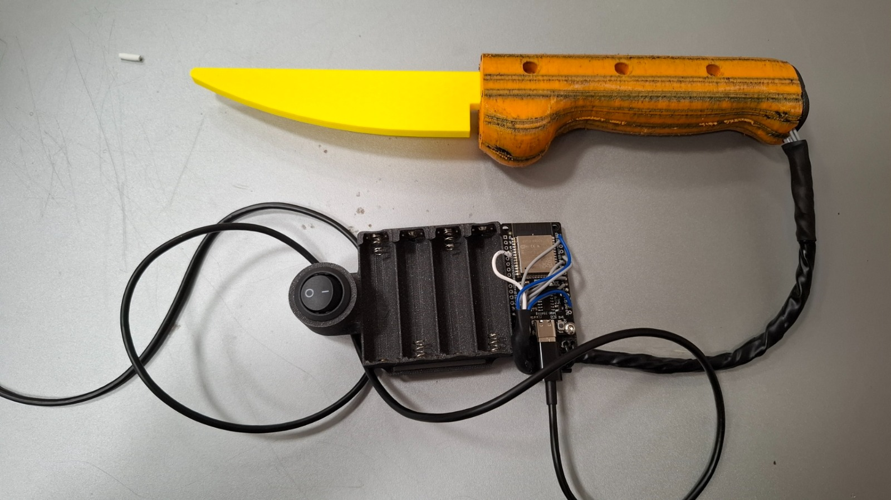
Figure 26 : 3D printed handle with integrated sensors

But this one was a prototype, and so there were several issues with it, which renders it unusable. In the future, with a functional 3D printed handle, it should facilitate the implementation of the IA.

Conclusion
This internship enabled me to manipulate several arm robots and several sensors, and I was able to enjoy working with the UR30, the last release of Universal Robot. It allowed me to explore further what I have learnt in class, both in terms of software with the algorithm of the admittance, the simulation or the ROS manipulation, and hardware with the implementation of sensors or the use of the teensy card.
I discovered the research field, and the feeling of encountering real problems, with sometime no solution other than change the method, like with Moveit which was not appropriate for this project.
I also learnt a lot on the use of github, which is very useful to make the future interns able to continue the work, or to keep my work on a cloud and be able to use it on other computers without storage device.
To conclude, this internship was very useful to refine my choice for my future job, I developed a better faculty to learn and a lot of mechatronic skills.

